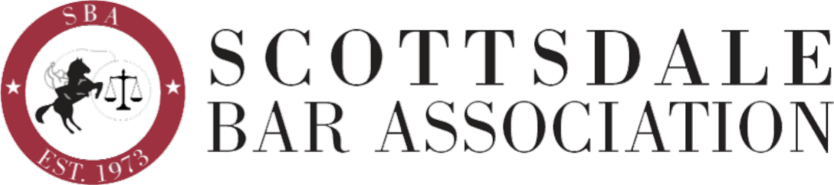

Event Sponsorship Form
CLE Luncheon: Law Firm Member Sponsor
Please spell sponsor name EXACTLY as you wish it to appear
Sponsor Name: Contact Name:
Contact Work Phone: Cell Phone: Contact Email:
Business Name:
Business Address: City: State: Zip+4:
Business Phone: Business Fax:
1) ____ Month of _________ 2022 $200
2) ____ 3 Month Package option $500
Month of ____________________
Month of ____________________
Month of ____________________
Sponsorships may recur every 3 - 4 months. Specific months are assigned on a first request basis and may already be 'sold'. Sponsorships not used within 12 months expire without a refund.
What a Sponsor receives:
- Two tickets to the Luncheon(s)
- Introduction at the Luncheon(s) and thanked by the President for their support
- 2 minute time frame for promotional work description by Sponsor
- Signage listing the sponsor(s) at each event
- Sponsor notation on SBA emails and website following event

Your commitment to sponsor and your payment must be received ten (10) days prior
to the event in order for your sponsorship to be listed on promotional materials.

Please return completed form with your check payable to Scottsdale Bar Association, to:
Perry L Goorman, 6624 East Aster Drive, Scottsdale, AZ 85254
{If payment by credit card is preferred, contact Alexis @ alexismerrittaz@yahoo.com for the form.}

For more information contact scottsdalebar@aol.com, or,
Perry at plgoorman@gmail.com, Wendy Anderson at wendy@wendyandersonlaw.com or David Schmidt at dschmidt@clarkhill.com

